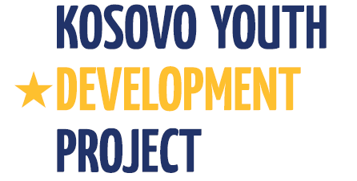
Kosovo Youth Development Project
Project Implementation Unit – PIU
Ministry of Culture, Youth and Sports / Department of Youth
Government of Kosovo

REQUEST FOR EXPRESSIONS OF INTEREST
Kosovo
Kosovo Youth Development Project 2
Grant No.:TF098547

Assignment Title: Kosovo Youth Development Project (KYDP) will contract a firm to conduct European Computer Driving License (ECDL) trainings to 12 officials of the Department of Youth

Reference No (as per Procurement Plan): 17.1

The Ministry of Culture, Youth and Sports/Department of Youth has received financing from the World Bank toward the cost of the Second Kosovo Youth Development Project, being implemented by the Project Implementation Unit, and intends to apply part of the proceeds for consulting services.

The objective of the assignment is to provide training to enhance computer skills for the DoY Officials in using information technology and different software programs based on the European Computer Driving License (ECDL) standards, using at least MS Office 2007

Specific tasks for the company will include:

- Consult with the Project Team for a general orientation of the program/project;
- Conduct a preliminary analysis to assess the needs of DoY Officials in relation to ECDL modules to determine the level ECDL competencies, and adjust the training program in accordance to that it is expected that each DoY participant will attend not less than 4 out of 7 ECDL modules
- The appraisal, development, organization and deliverance of training program;
- Conduct the testing of DoY officials in accordance with ECDL procedures in gaining the recognized license of computer knowledge – European Computer Driving License (ECDL).
- Trainings should be provided in Albanian

The approximate duration of assignment will be around 10 months, including testing part. The schedule and plan of assignment will be developed in close consultation and coordination with PIU and DoY.

Minimum qualification criteria:
- Be legally registered;
- Evidence the company is authorized to carry out ECDL trainings;
- Evidence on conducting ECDL training in the past
- A minimum of five years work experience and professional knowledge in development of training programs in relation to information technology;

Interested Consultants should provide information demonstrating that they have the required qualifications and relevant experience to perform the Services. The shortlisting criteria are:

Firm's experience in developing, organizing and implementing similar assignments (ECDL training) | 50 points
Availability of qualified key staff within the firm | 20 points
Organization of firm and staffing (including number of years in business; number of permanent staff within the firm) | 30 points

"A consulting firm will be selected using the selection based on Consultants Qualification (CQ) in accordance with the procedures set forth in the World Bank’s Guidelines: Selection and Employment of Consultants under IBRD Loans and IDA Credits & Grants by World Bank Borrowers (“Consultant Guidelines”), edition of May 2004, revised October 2006 and May 2010, para 3.7".
Further information can be obtained at the address below during office hours: 09: 00 to 16:00.

Expressions of interest must be delivered in a written form to the address below (in person, or by mail, or by fax, or by e-mail) by 21.05.2012

The Ministry of Culture, Youth and Sports/Department of Youth
Project Implementation Unit – PIU
Mother Theresa Square #35; Office #25;
10000, Prishtina, Republic of Kosova
Attn: Arton Çitaku – Procurement and Administration Specialist
Tel: +381 (0)38 200 22 081;
E-mail: arton.citaku@rks-gov.net

